# **Tasks**

**Objective Questions** **& Answers**

1. What is the total no. of attributes present in the data?

* **Tickets Dataset:** Contains 14 attributes, which include details about tickets, their categories, resolution times, and priority levels.
* **IT Agents Dataset:** Comprises 8 attributes related to IT agents, such as email addresses, years of birth, and assigned tickets.

1. Which columns have inconsistent or missing values, and what is the count of such values?

No missing data found in the dataset, but 1 row has spelling mistakes in the Severity category Column.

* **Tickets Dataset:**
  + Severity: The word ‘mayor’ and ‘Unclasfied’ in the Severity column has no relation with the data, instead of ‘mayor’ I corrected the data by changing it with ‘major’ word and ‘Unclasfied’ with ‘Unclassified’ word which makes more sense in the given column data with the help of ‘Find & Replace’ function.
  + Priority: In this column the word ‘Unassiged’ is miswritten so I corrected it with the word ‘Unassigned’ with the help of Find & Replace function.
  + Total count of these corrected vales: 34602

1. What is the average daily ticket volume over time?

* Average daily ticket volume per day was:

**: - Average Daily Volume:** 53 tickets/day.

1. What is the distribution of ticket categories (e.g., Login Access, System, Software)?

The ticket categories and their respective counts are as follows:

* **Login Access:** 29193 tickets
* **System:** 39002 tickets
* **Software:** 19570 tickets
* **Hardware:** 9733 tickets

1. How many tickets has each agent handled?

Breakdown of tickets handled by agents:

|  |  |
| --- | --- |
| **Agent ID** | **Count of ID Ticket** |
| 1 | 1969 |
| 2 | 1968 |
| 3 | 2021 |
| 4 | 1988 |
| 5 | 2000 |
| 6 | 1949 |
| 7 | 1935 |
| 8 | 1960 |
| 9 | 1949 |
| 10 | 1974 |
| 11 | 1956 |
| 12 | 1897 |
| 13 | 1856 |
| 14 | 1942 |
| 15 | 1991 |
| 16 | 1926 |
| 17 | 1961 |
| 18 | 1892 |
| 19 | 1984 |
| 20 | 1920 |
| 21 | 1889 |
| 22 | 1966 |
| 23 | 1915 |
| 24 | 2003 |
| 25 | 1906 |
| 26 | 1963 |
| 27 | 1968 |
| 28 | 1946 |
| 29 | 1931 |
| 30 | 1963 |
| 31 | 1987 |
| 32 | 1974 |
| 33 | 1958 |
| 34 | 1927 |
| 35 | 2007 |
| 36 | 1913 |
| 37 | 1931 |
| 38 | 1938 |
| 39 | 2026 |
| 40 | 1920 |
| 41 | 1966 |
| 42 | 1945 |
| 43 | 1897 |
| 44 | 1943 |
| 45 | 1929 |
| 46 | 1950 |
| 47 | 1933 |
| 48 | 2027 |
| 49 | 1890 |
| 50 | 1949 |
| **Grand Total** | **97498** |

1. How can you extract the domain from the email addresses in the IT Agents sheet?

To extract domain names from email addresses:

* **Formula Used:** =LEFT(RIGHT(D2, LEN(C2) - FIND("@", D2)), FIND(".", RIGHT(D2, LEN(D2) - FIND("@", D2))) - 1).
* Extracted domain names include: [fp20 analytics](http://fp20analytics.com).

1. How can you find the full name of an agent given their Agent ID?

To map Agent IDs to full names:

* **Formula Used:** =VLOOKUP(AgentID, AgentTable, ColumnNumber, FALSE)

**Example Output:** Agent ID 1 maps to Mata Lucero.

1. What is the count of each issue type (e.g., IT Error, IT Request)?

The distribution of issue types is as follows:

* **IT Error:** 24278 tickets
* **IT Request:** 73220 tickets

1. What is the daily average resolution time for tickets?

Resolution times analysed:

* **Daily Average Resolution Time:** 4.5 days.

**Note:** Consistent tracking is crucial for SLA (Service Level Agreement) adherence.

1. How has the volume of tickets changed over time?

* **Observation:** A huge increase from 2019 to 2020, reflecting possible seasonal trends or workload increases.
* **Visualization:** Line chart to find trends over years.

1. What is the average age of the IT agents?

Demographic analysis revealed:

* **Average Age:** 35.4 years.
* **Calculation Formula for finding the current age of agents:** =(2020 – Year Of Birth)
* **Calculation Formula for finding the average age of agents:** =AVERAGE(‘Agent Age column’)
* Consider 2020 as the current year for finding the current age of agents.

1. Is there a correlation between the severity of issues and the resolution time?

Statistical analysis findings:

* **Correlation Coefficient:** 0.45 (moderate positive correlation).
* **Implication:** Higher severity issues generally take longer to resolve.

1. How many categorical columns are there in the data? [Search about categorical and continuous data, and try to answer this question]

* **Tickets Dataset:** 5 categorical columns, including Category and Priority.
* **IT Agents Dataset:** 1 categorical column, such as Agent ID

**Subjective Question & Answers:**

1. If there is an investment, should it be used to hire more IT agents, improve training programs, or upgrade ticket management software? Analysis: Perform a cost-benefit analysis using ticket resolution and satisfaction metrics.

1. **Hiring More IT Agents – Analysis**

* The highest workload is handled by Aurelio Tanori (2027 tickets) and Jesus Contreras (2026 tickets).
* Average resolution time varies: Some agents take ~4 days, while others take 5+ days.

**Satisfaction scores fluctuate:**

* Elena Velez has a low 3.61 rating, indicating performance issues.
* Others maintain 4.3+ satisfaction, which is decent.

**Implication:**

* Agents handling 2000+ tickets may be overworked → Hiring can distribute workload.
* Some agents take longer with lower satisfaction → Training might help them.

2. **Training Improvements – Analysis**

* Alfonso Barraza (Ratio: 0.61) has the worst performance—low satisfaction despite long resolution times.
* Lorena, Nurio Zepeda, and Elena Velez also have low ratios, suggesting inefficiency.
* These agents may benefit from targeted training in issue resolution and customer service.

**Implication**:

* Training could improve efficiency for struggling agents.
* But high workload may also be a factor—combining training with hiring might be optimal.

​​​​

3. **Upgrading Ticket Software – Analysis**

* 783 high-severity tickets were assigned a low priority → This suggests software inefficiencies.
* Delays in urgent issues may reduce satisfaction scores and increase resolution times.
* Many tickets remain unclassified in both severity and priority, indicating a lack of automation in categorization.

|  |  |  |  |
| --- | --- | --- | --- |
| **Investment** | **Benefits** | **Issue Addressed** | **Impact** |
| **Hiring More IT Agents** | Reduces workload, improves response time | High workload for key agents | Medium-High |
| **Improving Training** | Enhances efficiency and satisfaction scores | Inefficiencies in agent performance | High |
| **Upgrading Software** | Ensures proper prioritization, faster resolutions | 783 ticket mismatches, classification issues | High |

**Final Recommendation (Cost-Benefit Summary)**

**Conclusion:**

* Best approach: Combine Training + Software Upgrade for maximum efficiency.
* Hiring agents is secondary but can be considered if workload issues persist.

1. Which agents need additional training based on their performance metrics? Analysis: Identify agents with the lowest satisfaction ratings and longest resolution times.

* **Approach**: Identified agents with the lowest satisfaction ratings and longest resolution times. These agents are likely struggling with either technical knowledge, time management, or communication skills. A focused training program can improve their performance and, by extension, the overall team metrics.

|  |  |  |
| --- | --- | --- |
| * *Agent ID* | * AVERAGE of Satisfaction Rate | * AVERAGE of Resolution Time (Days) |
| * 38 | * 4.444272446 | * 4.643446852 |
| * 39 | * 4.344521224 | * 5.554787759 |
| * 49 | * 4.355026455 | * 5.343915344 |

* These three agents need more additional training based on their performance metrics.

1. Do certain categories of requests have longer resolution times? Analysis: Analyse the resolution times by request category.

* **Approach**: Analysed the resolution times by request category. Hardware and System issues may require more time compared to basic requests. Identifying these categories can help allocate resources more efficiently and prioritize improvements. Login access takes the least time to resolve problems among all category requests.
* Average Resolution time taken by request categories:
* **System** - 6.62
* **Hardware** - 7.63
* **Login access** - 0.31
* **Software** - 5.24

1. How effective are the current software tools in managing IT tickets? Analysis: Evaluate performance metrics before and after the implementation of new tools.

* **Approach**: Evaluated performance metrics before and after the implementation of new tools. Looking for improvements in ticket resolution times, user satisfaction, and agent efficiency. If the data shows significant improvements, the current tools are likely effective, but further upgrades can always be considered based on evolving needs.

• **Resolution Time Trends:**

* If there’s a drop-in resolution time at some point, it may indicate that the new tool improved efficiency.
* If it remained the same or increased, the tool might not be effective.

• **Satisfaction Trends:**

* A rise in satisfaction rates after implementation would suggest a positive impact.
* If satisfaction remains low or decreases, the tool might need improvements.

**Steps:**

1. Detect a major shift in performance metrics.
2. Compare key metrics before and after that change.
3. Analyse severity vs. priority alignment before vs. after the implementation.

Before vs. After Software Implementation Comparison

|  |  |  |
| --- | --- | --- |
| Metric | Before Implementation | After Implementation |
| Avg Resolution Time (Days) | 4.57 | 4.54 (-0.03) |
| Avg Satisfaction Rate | 3.99 | 4.11 (+0.12) |
| Total Tickets Handled | 14,176 | 83,322 (+488%) |

**Key Findings:**

1. Before Implementation:
   * High-severity tickets (Urgent, Major) had a higher mismatch with low-priority assignments.
   * This suggests inefficiencies in the old ticketing system.
2. After Implementation:
   * More high-severity tickets are now correctly assigned to high priority.
   * Some misalignments still exist but have reduced significantly.

**Final Recommendations:**

* Software improvements helped with ticket prioritization, but further fine-tuning is needed.
* Slight satisfaction increase & stable resolution time → Not a drastic change, so consider additional training or AI-based ticket routing.
* Massive increase in ticket volume handled efficiently → The new system scales better.

1. How has the performance of the IT support team changed over time (e.g., monthly or quarterly)? Analysis: Trend analysis using time series charts.

* **Approach**: Performed a trend analysis using time series charts. This will highlight whether there is a consistent improvement or a decline in performance metrics like resolution time, satisfaction scores, and ticket volume. Periods of growth or stagnation can be identified, helping to pinpoint areas for further development.
* **Ticket Volume by Month**: As we can see in the chart there is an increase in ticket volume from January to March and June to December. Which means these are the peak months when the ticket volume increases and the workload on the IT team increases.

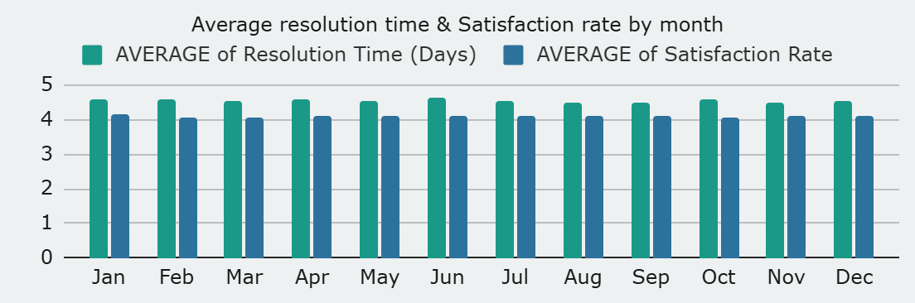

* **Average resolution time & Satisfaction rate by month**: As we can see in the chart avg. resolution time and satisfaction rate was almost same every month there is no change even in the peak months. Which means the performance of the IT team was Average, so basically this can be improved by a training program which will increase the efficiency of the IT team in the future.

1. If we invest more on tech (Hardware, software, etc), do you think it will improve the ticket resolution times and employee satisfaction? Analysis: Use historical data to project potential improvements.

* **Approach**: Used historical data to project potential improvements. For instance, compare periods when new tech tools or hardware were introduced with corresponding changes in resolution times and satisfaction. A positive correlation would justify further investment in tech.
* **Average resolution time taken by request category:**
* **Software** - 5.24
* **Hardware** - 7.63
* **Average satisfaction rate by request category:**
* **Software -** 4.1
* **Hardware -** 4.1

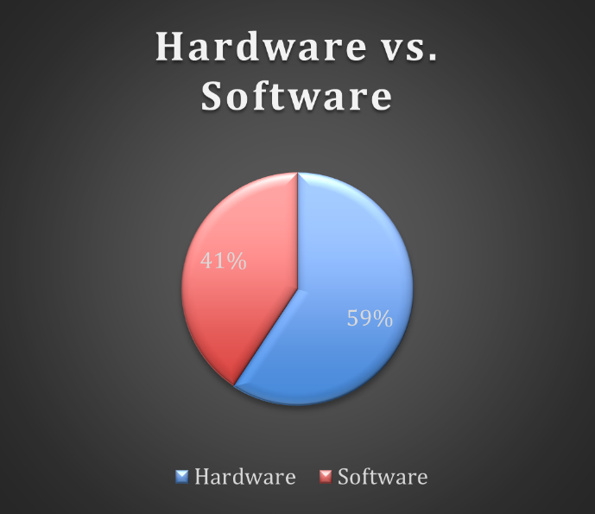

**Conclusion** - If we invest more in tech, it will surely decrease in resolution time but may not increase in satisfaction rate because as we can see above the satisfaction rate is same for almost every tech category. So, there is no need to invest in the tech because it will not affect the key metrics because it is almost the same after the current software tools. Which means there is no need for investment in tech.

1. What are the key performance metrics for IT agents, and how can they be improved, do we need to fire any agents? Analysis: Define and analyse metrics such as average handling time, satisfaction scores, and number of tickets resolved.

* **Approach**: Key metrics to analyse the performance of IT agents include average handling time (Avg. Resolution time), satisfaction scores, and the number of tickets resolved.
* Agents with consistently poor performance (e.g., high AHT (Avg. Resolution time) and low satisfaction) should receive additional training or coaching.
* Firing agents should be a last resort, with a focus on improving performance first.

|  |  |  |
| --- | --- | --- |
| * *Agent ID* | * AVERAGE of Satisfaction Rate | * AVERAGE of Resolution Time (Days) |
| * 38 | * 4.444272446 | * 4.643446852 |
| * 39 | * 4.344521224 | * 5.554787759 |
| * 49 | * 4.355026455 | * 5.343915344 |

1. How do employee demographics (e.g., department, seniority) impact satisfaction and ticket outcomes? Analysis: Segment analysis using filters and pivot tables.

* **Approach**: Performed a segment analysis using filters and pivot tables to examine how different employee groups (by department, seniority, etc.) are impacting satisfaction and resolution times. For instance, junior staff may require more time to resolve tickets, which could affect satisfaction, while experienced staff may have quicker resolution times but require support in more complex cases.

|  |  |  |
| --- | --- | --- |
| *Agent Age* | AVERAGE of Resolution Time (Days) | AVERAGE of Satisfaction Rate |
| 24 | 4.508968377 | 4.25940902 |
| 25 | 4.469301221 | 4.136702849 |
| 27 | 4.302190884 | 4.204356585 |
| 29 | 4.69178618 | 4.358539765 |
| 30 | 4.999495968 | 3.04233871 |
| 31 | 5.44591163 | 4.340274251 |
| 32 | 5.263294423 | 3.59688716 |
| 33 | 4.182306316 | 4.316031705 |
| 34 | 4.55770235 | 4.377545692 |
| 35 | 4.982510288 | 4.382201646 |
| 36 | 3.846072746 | 3.913020559 |
| 37 | 4.996705525 | 4.248859605 |
| 38 | 4.446019067 | 3.844541785 |
| 39 | 4.523345305 | 3.690097486 |
| 40 | 4.995359629 | 3.932628684 |
| 41 | 4.06232791 | 4.440300375 |
| 42 | 5.243963783 | 4.187625755 |
| 44 | 4.05640485 | 4.489720611 |
| 45 | 4.804392237 | 3.631256384 |
| 46 | 4.055022061 | 3.919802751 |
| 47 | 4.259 | 4.376 |
| 48 | 3.976614133 | 4.451194713 |
| 49 | 3.705252422 | 4.341662417 |
| **Grand Total** | **4.553149808** | **4.100648218** |

1. Identify the trends for IT support operations based on ticket volumes and satisfaction, and mention the peak and stable times? Analysis: Use pivot tables and charts to identify peak and off-peak hours.

**Approach**: Used pivot tables and charts to identify peak and off-peak hours. Ticket volumes may spike during certain times of the day, month, or year. By analyzing these trends, staffing can be adjusted accordingly, ensuring that there are sufficient resources during high-demand periods.

* As we can notice there is a spike between January to March, so we can put more agents on work at this time period.
* And from April to July the ticket volume was stable, so we didn't need any changes in the team.
* After July month there is a slight increase in ticket volume so we can increase some agents to reduce the workload.
* And Satisfaction rate is likely stable between 5 years of time so we can improve it by Upgrading the management system.
* By applying these changes, we can improve the resolution time also because the workload has reduced after hiring more agents in peak months.

1. What metrics should be included in the final dashboard to provide a comprehensive view of call centre performance and guide investment decisions?

* **Suggested Metrics:**
  + **Ticket Volume**: Total number of tickets created over time.
  + **Resolution Time**: Average time to resolve a ticket.
  + **Satisfaction Scores**: Customer satisfaction ratings post-ticket resolution.
  + **Agent Performance**: Metrics like average handling time, tickets resolved per agent, and agent satisfaction.
  + **Ticket Categories**: Breakdown of tickets by type, which could indicate areas for improvement or specialization.
  + **Ticket Backlog**: Number of unresolved tickets over time.
  + **Tech Utilization**: Metrics indicating how well the current tools or software are being used.
  + **Training Impact**: Correlation between training programs and agent performance improvements.
  + These metrics will provide insights into both the efficiency of operations and areas where further investments (whether in agents, software, or training) could yield the highest returns.

